FORTRAN BOARD SURFACE CLEANING MACHINE
Daily Maintenance & Service Guide

Panel Cleaning Expert | Proprietary Patented Technology | All Rights Reserved

01 | Consumable Replacement Schedule
Replace consumables on schedule to maintain optimal cleaning performance.
Consumable | Qty per Change | Change Interval | Reuse Cycles | Reuse Condition | Discard Condition
White water-dispensing cloth  (Water Pad) | 8 pcs | Every 1 day | 3 cycles | Wash after each use (initial use + 2 washes) | Discard when worn
Grey anti-static wiping cloth  (Anti-Static Pad) | 6 pcs | Every 2 days | 3 cycles | Wash after each use (initial use + 2 washes) | Discard when worn
Jute/hessian scrubbing cloth  (Jute Pad) | 8 pcs | Every 3–5 days | Up to 5–7 days | Continue use if intact | Replace when torn or degraded
Black hook-and-loop wiping cloth  (Burr Pad) | 2 pcs | Every 2 days | Single use | — | Replace immediately when damaged
White foam pad  (White Sponge) | 14 pcs | Every 1 day | Single use | — | Replace immediately when damaged
Black foam pad  (Black Sponge) | 10 pcs | Every 3 days | Single use | — | Replace immediately when damaged
Velcro edge strips  (Hook-and-Loop Strips) | 48 strips  (24 sets) | Every 2 months | Single use | — | Replace when adhesion is lost

02 | Cloth & Foam Pad Pairing Configuration
Each replacement spindle assembly uses a paired cloth-and-foam combination as specified below.
The machine is equipped with 24 wiper spindles in total, arranged in two rows (12 spindles per row, upper and lower). All pairing quantities below refer to one full replacement set.

Cloth Type | Foam Pad Type | Spindles per Set | Mounting Note
White water-dispensing cloth (Water Pad) | White foam pad | 8 spindles | Paired set
Grey anti-static wiping cloth (Anti-Static Pad) | White foam pad | 6 spindles | Paired set
Jute/hessian scrubbing cloth (Jute Pad) | Black foam pad | 8 spindles | Paired set
Black hook-and-loop cloth (Burr Pad) | Black foam pad | 2 spindles | Paired set
Velcro edge strips | — | 2 strips per spindle | Secured with screws on both sides of replacement spindle; 24 spindles x 2 strips = 48 strips total

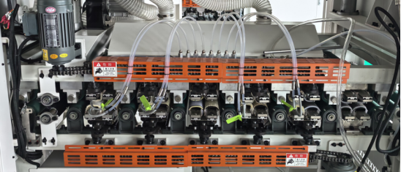

03 | Wiper Spindle Layout & Cleaning Sequence
Spindles are arranged in 6 groups of 4 (left to right), covering the full cleaning cycle in sequence.
Group | Position (L to R) | Spindle Configuration | Function
1 | Group 1 | Water Pad (water dispensing) + Jute Pad | Pre-wet panel surface; initial scrub to loosen debris
2 | Group 2 | Water Pad (water dispensing) + Jute Pad | Second wet scrub; deeper cleaning pass
3 | Group 3 | Burr Pad (hook-and-loop) + Jute Pad | Adhesive/glue residue removal; secondary scrub
4 | Group 4 | Water Pad (water dispensing) + Jute Pad | Final wet scrub; surface rinse
5 | Group 5 | Water Pad (water dispensing) + Anti-Static Pad | Controlled rinse; initial moisture removal
6 | Group 6 | Anti-Static Pad + Anti-Static Pad | Final moisture wipe-down; anti-static finish

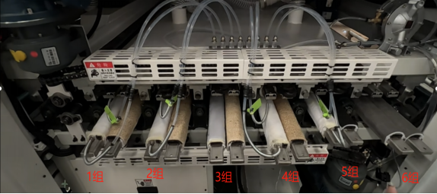

04 | Operating Procedures & Maintenance Precautions

A | Pre-Operation Checks & Panel Feeding

Before loading panels, verify that the pressure beam height is set to match the panel thickness.
Minimum panel length: 350 mm. Panels shorter than 350 mm must NOT be fed into the machine.
When loading panels, leave a 15–20 mm clearance on both sides relative to the machine width. Fill the centre space fully — this improves cleaning efficiency and reduces water consumption.

B | Water Dispensing System

At the start of each shift (morning, midday, and end of day), and whenever the machine has been idle for 15 minutes or more without feeding panels, perform a manual water dispensing cycle before resuming operation.
Recommended water dispensing interval: 250–500 seconds. Dispensing duration per cycle: 3–5 seconds. Adjust based on panel contamination level and feed speed.
Note: The cloth bracket fitted with the water supply tube is directional — upper and lower positions must NOT be swapped.

C | Routine Inspection & Periodic Maintenance

Freq. | Inspection Item | Action Required
Each shift  (start & end) | Inspect all wiper cloths and jute pads for wear or damage | Replace immediately if torn, frayed, or otherwise degraded
Each cloth  change | Check Velcro strip adhesion on replacement spindles | Replace strips if adhesion is insufficient
Each cloth  change | Check guide sliders for wear | Replace worn sliders promptly to maintain feed accuracy
Monthly | Inspect sprocket mounting bolts for looseness | Re-tighten any loose fasteners; torque to specification
Monthly  (approx.) | Lubricate drive chains | Apply grease to all drive chains; use an appropriate machinery grease

REF | Technical Terminology Reference

Technical Term | Description / Usage Note
Water Pad (Water-Dispensing Cloth) | White wiper cloth with integrated water supply line; pre-wets the panel surface prior to scrubbing
Anti-Static Pad | Grey anti-static wiper cloth; used for final moisture removal and electrostatic discharge on cleaned panels
Jute Scrubbing Cloth | Coarse-woven jute fabric; primary mechanical scrubbing element for removing surface debris and contaminants
Burr Pad (Hook-and-Loop Wiper) | Black micro-hooked fabric wiper; specifically designed to strip adhesive residue, glue spots, and cured deposits
White Foam Pad | Open-cell polyurethane foam backing; paired with Water Pad and Anti-Static Pad for cushioned moisture absorption
Black Foam Pad | Dense foam backing pad; paired with Jute Cloth and Burr Pad to provide firm scrubbing support
Velcro Edge Strips (Hook-and-Loop Retaining Strips) | Adhesive-backed fastening strips securing wiper cloths to spindle ends; replace when holding force is insufficient
Replacement Spindle Assembly | Modular wiper spindle unit pre-loaded with cloth and foam pad; designed for rapid tool-free changeover
Pressure Beam | Horizontal clamping beam that applies calibrated downward pressure to panels during the feed cycle; must be set to panel thickness before operation
Water Supply Bracket | Cloth-holding bracket with integrated water feed tube; positional — upper and lower orientations are not interchangeable
Guide Slider | Linear bearing slider maintaining lateral panel alignment throughout the feed path; replace when wear affects tracking accuracy
Drive Sprocket | Toothed sprocket wheel transmitting rotational drive to the conveyor chain system
Drive Chain | Roller-link conveyor chain; requires greasing approximately every 30 days to prevent wear and elongation
Panel Feed Cycle | Single pass of a panel through the full cleaning sequence from entry to exit
Manual Water Prime | Operator-initiated water dispensing cycle performed before resuming production after idle periods of 15 minutes or more

This document is for authorised distributors and operators only. All technical content, product designs, and specifications remain the exclusive intellectual property of Guangdong Fortran Machinery Co., Ltd. Unauthorised reproduction or distribution is strictly prohibited.

GUANGDONG FORTRAN MACHINERY CO., LTD | Fortran Board Surface Cleaning Machine | Maintenance Guide

